Let’s talk about microcontrollers.
This is the one Grandpa gave me.
It’s an Arduino-compatible microcontroller based on the Arduino Uno.
You say it like this: Are – Du – Eee – No.
It’s an Italian word.
A microcontroller is a miniature computer that does a specific job within a larger machine or system. Microcontrollers are everywhere these days. All the so-called “smart” devices in our lives are smart because of these miniature computers inside of them.
In 2005, an Italian company named Arduino started making an inexpensive, multi-purpose microcontroller that anyone could use to build anything they wanted to build, and in 2010, they introduced the Arduino Uno, which because their most popular design for a long time after that.
Even today, all these years later, the Arduino Uno is still widely used by makers all over the world whenever they want to build something cool that needs a little electronic brain inside of it.
Like, say, a robot.
And a really awesome thing that Arduino did with their microcontrollers: they made them open source, which means they allowed anyone who wanted to copy the design and build their own, which ensured that Arduino-style microcontrollers were widely available everywhere and always nice and cheap. Today, if you’re using a microcontroller that’s built by Arduino, we typically call at an Arduino. If it was made by someone else using Arduino’s open-source design, we call it Arduino-compatible.
Open source is a pretty awesome thing, and because of it, quietly, there are Arduinos and Arduino-compatible devices everywhere making our lives easier and more fun. Scientists and engineers use them in prototypes of electronic builds. Tinkerers use them to make their own robotic devices and smart devices. Teachers use them all the time to teach the basics of electronics, robotics, and embedded systems.
And it’s super common for big companies to build first draft prototypes with Arduinos and then, when they build the final product, to create their own microcontroller that perfectly fits the system they’re making.
I learned all of this over time. On that first day when Grandpa showed me how to make an LED blink using an Arduino, I didn’t know any of it yet.
All I knew is what Grandpa taught me.
“The first thing we need to do is download the Arduino I.D.E. from the Arduino web site,” he said.
IDE stands for Integrated Development Environment — a fancy way of saying ‘a program for writing computer programs.’ You’ll see it written like this: Arduino IDE. But say each letter: Arduino I – D – E. Don’t say Arduino I’d. In fact, if you hear someone say I’d rather than saying every letter (I – D – E), it is your job as a programmer to immediately say back to them “I’d like an egg salad sandwich.”
To download the Arduino IDE, you must go to the Arduino web site. Go to arduino.cc and navigate to products then software.
This is the web site I brought up. Note the address:
(screenshot https://www.arduino.cc/en/software/)
Then you download and install the Arduino IDE.
Grandpa and I installed the software on my laptop. It only took a minute. Then we opened it. It looked like this:
(screenshot Arduino IDE first screen)
“When you built the circuit the first time, you had a battery power the LED,” Grandpa said. “But now the microcontroller is going to power it.”
“So it works like a battery?” I asked.
“For this first circuit, you’ll have the microcontroller plugged into your computer. Your computer will power the microcontroller and it will power your circuit.”
I looked again at my circuit on the breadboard. All it needed was power (show sketch).
“We have to program the microcontroller to send pulses of electricity, on and off, so the LED blinks,” Grandpa said. “I’ll help you write the code.”
I’m going to show you the exact program Grandpa and I wrote that day. You’ll have to open the Arduino IDE and make the screen look exactly like mine.
I’m only going to show you the correct program, but you should know that I made a lot of mistakes before I got it right. It’s ok if you make mistakes too. The software will tell you that you did. You’ll see.
One more thing: before this book is done, you’re going to know precisely what each line of this program does and you’ll be able to write your own programs like it. But for now, just type it in, and as you do, see if can figure out what might be going on.
Here’s the code we wrote:
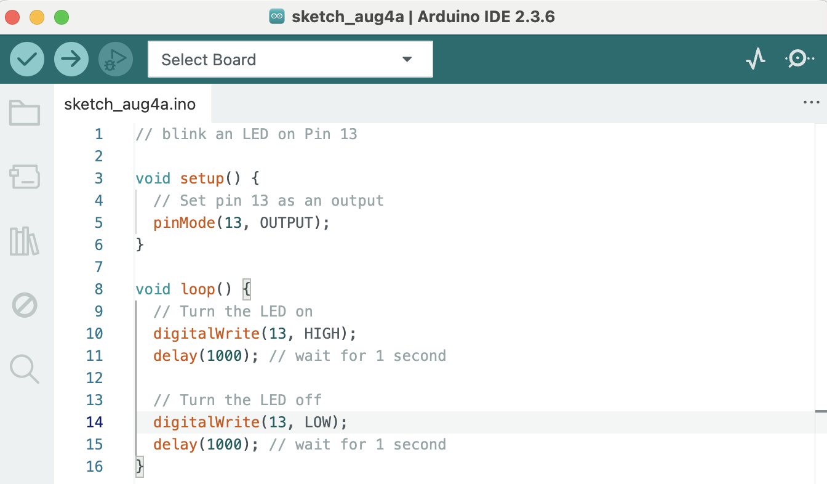
“Alright, I’ve typed it in,” I said. “Now what?”
“Now we have to load the code onto the microcontroller,” said Grandpa.
As you may have already guessed, we can connect the microcontroller to the computer using a USB cable, like this:
(show sketch)
We connected our microcontroller.
“Choose that Select Board dropdown,” said Grandpa.
I clicked it and saw our board listed — on yours it’s probably something like ‘Arduino Uno’ or ‘COM3’. We selected it.
(show screenshot)
You’ve seen that there are two buttons on the top left of the window for the Arduino IDE. One is a checkmark, and one is an arrow. If you hover your mouse over them, they tell you what they are.
(show screenshot and captions)
Click the Check Mark. This checks your code for typos and formatting errors. If all is well, you’ll see this:
(show screenshot)
Note: if you got some kind of error at this point, congratulations! You’re a real programmer now! Programming is all about fixing errors. See if you can figure out where you went wrong. If you’re totally stuck, go to gavinholloway.com and watch the video called “Blinking an LED.”
One more step needed to load the program on the microcontroller. Take a guess what it is.
Right! We need to press the arrow button.
(show screenshot)
Do you notice something happening that maybe wasn’t happening before?
The LED on your microcontroller is blinking!
(sketch)
That’s your first sign that the program is working. That LED on the microcontroller is meant to give a visual cue to you, the programmer, about how the program is doing, even before you hook up the microcontroller to your circuit.
Which we’re going to do now!
So here’s my circuit on the breadboard, except I have the battery disconnected. This is what I was looking at when Grandpa said, “Now connect Pin 13 to the positive side of the LED.”
Do you remember which side of the LED was positive? If not, go back and look at Chapter 2.
Let’s connect a red wire from Pin 13 to the Positive Rail on the breadboard, like this:
(sketch – caption – technically it would work with any color wire, but it’s good practice to use a red wire for positive if you have one).
“But what about the negative?” I said, remembering that we connected the black wire from our battery to the other side of the breadboard.
“Connect the negative side of the LED to ground,” said Grandpa.
“What’s that mean?” I said.
“Put it in the GND pin of your Arduino.”
Hopefully, you’re looking at your microcontroller now, and thinking about connecting the negative side of LED to ground.
What color wire do you think you should use? Truth is you could use any color and it will work, but what’s the convention in electronics?
Black wire to negative! Right!
You ready to see how we did it? Have a look at the next sketch.
(show sketch. Caption…see how the pin right next to 13 is labeled GND? That stands for “Ground.”)
Here’s the whole setup:
(show entire circuit).
Does yours blink?
Mine did. And when it did, I raised both fists like I’d won the Olympics, because I had just told a machine what to do, and it listened.
As soon as you get yours working, you should allow yourself a moment of joy as well, because it is kind of a big deal.
You just programmed a microcontroller and built it into a circuit.
And that’s exactly how people build robots.

For full step by step instructions, including instructions for different types of computers, go to gavinholloway.com/Arduino

